Applecross Community Company

Invitation to Tender for Operations Manager for
Clear-felling Torgarve Community Woods

3rd December 2020

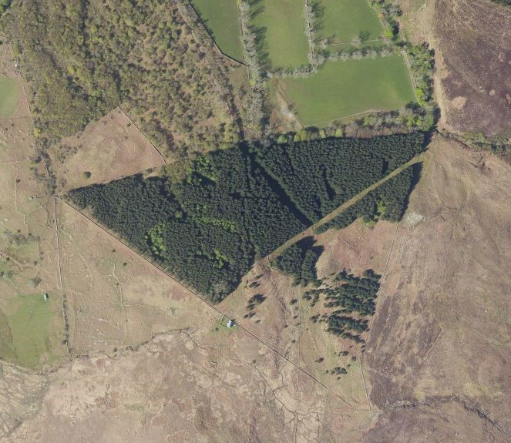

1. Introduction and Background

1.1 Background to Applecross Community Company

Applecross Community Company (ACC) is a community development trust, is registered in Scotland as a charity and a company limited by guarantee. It is governed by a volunteer board of directors and it currently has 103 members. ACC represents the Applecross community and its purpose, as defined by its articles of association, is “to manage community land and associated assets for the benefit of the Community and the public in general”.

ACC was established in 2008 and during its existence it has been responsible for many community projects including:
- the purchase and management of the local filling station (2008);
- the purchase and management of the local public toilets (2012);
- the establishment and management of the local community broadband (2014); and
- the establishment of a local 90kW hydro scheme (2016).

In addition, ACC has recently been working on the following projects:
- The development of an affordable housing project in the village of Camusterrach..
- The development of affordable housing and workshop space on the ‘Hydro Field’ in Applecross. Land acquisition is expected to complete by March 2021.
- The establishment of the Appleseed community allotments and garden.
- The Active Applecross community eBike scheme.
- A support scheme for the Applecross community during the Covid-19 pandemic.
- The development of a 5-year strategic plan. This is based on a 2018 community survey which purpose was to understand the community’s current needs, ideas and aspirations for the area.
- The development of a Community Land Use Plan project “Plan It Applecross”. This project was developed on our behalf by PAS, and was in close collaboration with The Applecross Trust, local stakeholders, the wider community and the Highland Council. The project was community led and involved a community charrette and extensive consultation.

ACC has many volunteers from the community and our company would not function without their input. ACC currently employs two part-time local development officers (fully funded by HIE until March 2022) to manage the development of projects.

1.2 Introduction to the Torgarve Community Woodland site

The Applecross Peninsula is located in Wester Ross, covering around 26,000 hectares (ha) with a population of 225. Almost all the land on the peninsula is owned by the Applecross Trust (the Trust).

ACC is in the process of acquiring the 14.28 ha “Torgarve Woodland” site from the Trust through a negotiated sale as a result of funding being agreed by the Scottish Land Fund in 2020. The woodland is a primarily Sitka Spruce commercial plantation, planted in 1973, located 700m from the Applecross Mains and Campsite – see Map 1 (Annex 1).

The site is enclosed within a larger deer-fenced area and is surrounded by common grazings, open moorland, a tenanted farm and ancient hazel woods; all owned by the Trust. There is a way-marked archaeological trail through the woods, a rough vehicle access track crosses the site to a Trust-leased cottage (located outwith the site, on common grazings), and it is trisected by SSE powerlines. Applecross Primary School Forest School activities take place regularly within the woodlands. The area contains a diverse range of archaeological sites from across the historical and prehistorical periods from iron age round houses to grain dryers to 17th and 18th C field systems and homesteads. An archaeological survey has been undertaken of these sites which has made recommendations about how they should be protected during and after the clear-fell activities, and during subsequent re-stocking. The site also contains two entrances to extensive thin Jurassic limestone caves (Uamh nam Fior Iongantais) which are reportedly important in terms of scale and beauty.

Following acquisition of the woodland, ACC plans to clear-fell the majority of the plantation and re-stock the area with a more diverse range of native woodland species, given the age and maturity of the Sitka Spruce. Map 1 indicates the site, its boundary and access points (A through to D). This map also illustrates that over 5ha (37%) of the site is currently open ground and that the clear-felling operations are expected to focus only on compartments 1 to 6, leaving compartment 7 intact. The proposed route for extracting the clear-felled timber is indicated by the blue line in Map 2 (Annex 2); extracting timber to the main road along an existing path and through the recently felled ‘Smiddy Woods’ area, both areas owned by the Trust. The timber will need to be transported to mill along the Applecross “coast road” (C1019) to Shieldaig and then through Lochcarron to the A890. The temporary use of land owned by the Trust for extraction and lay-down points along this route has been agreed in a Heads of Terms between ACC and the Trust.

The Torgarve Woods will be managed by ACC as a community woodland project, with support from a volunteer Community Woodland Steering Group. The Operations Manager role will be managed by the interim Community Woodland Development Officer and overseen by the Steering Group and the ACC Board of Directors. One specific Board member has been appointed as Project Director for the Torgarve Woods project.

2. Operations Manager Role

2.1 Scope of Work and Expected Outputs

The purpose of the role of Operations Manager is to provide professional support to the ACC Board on a short-term contract basis, during the preparation for and undertaking of the clear-fell operations for Torgarve Woods. This role is expected to cover around 14 days FTE over a period of approximately six months. During this time, the Operations Manager is expected to lead on a number of key tasks, namely:
- Land registration with Rural Payments and Inspections Directorate;
- Securing felling permission from Scottish Forestry;
- Obtaining necessary planning consents for roading from Highland Council;
- Confirming access agreements with the Trust and other interested parties;
- Tendering the roading and harvesting contract(s), and supporting ACC as required through the duration of the contract(s).

It is also expected that the Operations Manager shall build the capacity of the members of the ACC Board and Community Woodland Steering Group, as appropriate. Responsibility for the discussion of detailed arrangements e.g. with SSE for line de-energisation and with Highland Council for timber transport, will lie with the harvesting contract holder.

This role will be funded through a revenue grant received from the Scottish Land Fund. ACC expects to appoint this role from outwith Applecross. Regular online meetings shall be organised between the Operations Manager and those responsible for the project. A limited number of site visits and face-to-face meetings with those managing the project are also expected to take place (Covid-19 government restrictions allowing), particularly during the clear-fell operations.

We are hoping that the acquisition and clear-fell process can be undertaken within the following approximate timeframe. However we understand that there may be delays to this as a result of Covid restrictions and other factors:
- December 2020, Operations Manager hired and ready to start work once the acquisition is finalised
- January 2021, acquisition of the site by ACC completed
- February to April:
  - permissions from Scottish Forestry, Highland Council and other relevant bodies approved
  - roading work contract approved and work completed
  - clear-felling contract approved
- May to June, clear-felling, extraction and transportation undertaken
- July 2021, project completed (including reinstating the extraction route) and Operations Manager role ends

Expected outputs from the role:
- All required permissions and administrative tasks completed within a timely manner
- The clear-fell process successfully and safely undertaken and the timber sold at a fair market price
- Capacity of the ACC Board and Community Woodland Steering Group increased in relation to the project’s management
- Regular verbal and written updates provided in a timely manner to those responsible for the project
- All relevant documentation and paperwork handed over to ACC on the completion of the project. Copyright of any documented outputs is to be vested in ACC

The Operations Manager role will be complete once the clear-felling has been undertaken, the temporary extraction route has been reinstated, and the timber sold. ACC then hopes to hire a part-time Development Officer to work on the community woodland project in the longer term, a role responsible for the forest creation and restocking activities, volunteer management and implementation of the communities’ wider development aspirations for Torgarve Woods.

2.2 Form of Tender

Applecross Community Company wish to commission a consultant/team of consultants with knowledge and experience of woodland management, community enterprise, community consultation and purchase of land on behalf of local communities. The successful applicant(s) will demonstrate:
- Significant experience in the planning and preparation for the clear-felling and sale of Sitka Spruce and or similar species, in equivalently remote locations to Applecross, including the acquisition of relevant permissions, eg from Scottish Forestry and local planning authorities
- Significant experience overseeing clear-felling operations in similar conditions to the Torgarve Woodlands
- Experience of working with wider stakeholders and community groups, including capacity building
- Value for money.

The tender should include:
- The cost of undertaking this role, inclusive of fees, expenses, meetings and VAT
- CV(s) providing background information of the consultant(s) to be involved and examples of recent projects they have worked on which are similar in type and scale to the current proposal
- Names of two references from two separate organisations which the consultant(s) have undertaken similar roles, one to be within the last two years, who can be approached for references
- A timetable showing the various milestones required to complete the project

ACC also expects the consultancy team to have their own appropriate professional indemnity and other insurances.

Selection will be based on a criteria matrix put together to determine the most appropriate partners to engage with Applecross Community Company. It is expected that the selection will be based on 70% quality and 30% cost.

2.3 Budget

The indicative budget for this project is £6,300.00, inclusive of VAT and all associated costs. This funding has already been secured by ACC from the Scottish Land Fund.

Please itemise costs for activities undertaken to fulfil the Operations Manager role and likely travel/incidental expenses incurred in carrying out the work.

Recovery of Costs – The consultants hired will not be entitled to claim from ACC any costs or expenses incurred in preparing the tender, whether or not it is successful.

2.4 Closing date for tenders and preferred timeframe

The deadline for submission of the tenders is 5pm on 18th December 2020 and should be by email to Saara Viitanen on info@applecrosscommunitycompany.org.

ACC may at its discretion extend the closing date and time for receipt of tenders by written notice to all Tenderers.

2.5 Confidential Information

All information provided by ACC to Tenderers must be treated in strict confidence and must not be disclosed to any third party except so far as necessary in order for the Tenderer to obtain any sureties or quotations for the purposes of compiling and submitting the tender.

All information provided by Tenderers to ACC will be treated in confidence except as follows:
- References may be sought from existing and past clients and other referees in accordance with authorisations given by Tenderers in their tenders.
- Disclosure as may be required by the Freedom of Information Act 2000.

3) Contact details and acceptance of tender

Any questions regarding this tender brief should be addressed to Saara Viitanen on info@applecrosscommunitycompany.org by 15th December 2020. Written queries will be circulated to all tenderers by email.

ACC reserves the right:
- not to accept any tender, and
- to accept any tender or tenders in whole or in part.

For further information see: http://www.applecrosscommunitycompany.org/
The final version of the Land Use Plan is available here: http://www.applecrosscommunitycompany.org/index.asp?pageid=695244
The Applecross Trust was established in 1975 and according to their website “The owners of the Applecross Estate wished to preserve the outstanding natural beauty and wilderness heritage of the peninsula for the public benefit, and manage it in a sustainable, progressive manner; this was the catalyst for the charity which exists today”. For further information see: https://applecross.org.uk/
http://coilleais.com/liars-sink/
As outlined in the ACC (2020) Feasibility Study and Business Plan for Torgarve Community Woods: https://www.applecrosscommunitycompany.org/company-projects/community-woodlands/

